Branches: ME
Regulation: R19
Subject with Code: STRENGTH OF MATERIALS (19CE0150)
Year & Sem: II-B.Tech &I-Sem
SIDDARTHA INSTITUTE OF SCIENCE & TECHNOLOGY, PUTTUR
Siddharth Nagar, Narayanavanam Road – 517583

QUESTION BANK (DESCRIPTIVE)

UNIT I
(Simple Stresses and Strains, Theories of failure)
1 | Write a note about  (i) Hooke’s Law,  (ii) Lateral strain,  (iii) Poisson’s ratio,  (iv) Volumetric strain,  (v) Factor of safety,  (vi) Modulus of elasticity | L1  L1  L1  L1  L1  L1 | 2M  2M  2M  2M  2M  2M | CO1  CO1  CO1  CO1  CO1  CO1
2 | A tensile test was conducted on a mild steel bar. The following data was obtained from the test :  (i) Diameter of the steel bar = 3 cm  (ii) Gauge length of the bar = 20 cm  (iii) Load at elastic limit = 250 kN  (iv) Extension at a load of 150 kN = 0.21 mm  (v) Maximum load = 380 kN  (vi) Total extension = 60 mm  (vii) Diameter of the rod at the failure = 2.25 cm.  Determine :  (a) The Young's modulus,  (b) The stress at elastic limit,  (c) The percentage elongation, and  (d) The percentage decrease in area. | L3 | 10M | CO1
3 | A member ABCD is subjected to point loads P1, P2 , P3 and P4 as shown in figure. Calculate the force P2 necessary for equilibrium, if P1=45 kN, P3 =450 kN and P4=130 kN. Determine the total elongation of the member, assuming the modulus of elasticity to be 2.1 x 10⁵ N/ mm²  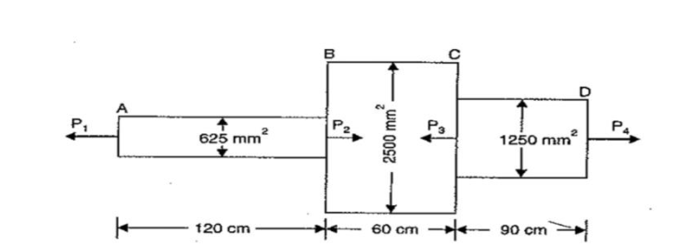 | L3 | 10M | CO1
4 | Two brass rods and one steel rod together supports a load as shown in fig. If the stresses in brass and steel are not to exceed 60 N/mm² and 120 N/ mm² , find the safe load that can be supported. Take E for steel = 2x105 N/ mm² and for brass =1x10⁵ N/ mm². The cross-sectional area of steel rod is 1500 mm² and of each brass rod is 1000 mm²  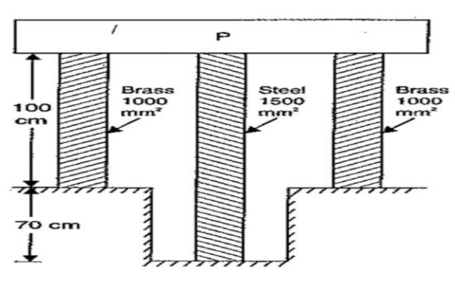 | L3 | 10M | CO1
5 | (a) Calculate the modulus of rigidity and bulk modulus of a cylindrical bar of diameter 30 mm and of length 1.5 m if the longitudinal strain in a bar during a tensile stress is four times the lateral strain. Find the change in volume, when the bar is subjected to a hydrostatic pressure of 100 N/mm². Take E =1 x 10⁵ N/mm².  (b) Define Mohr’s circle? | L3  L1 | 7M  3M | CO1  CO1
6 | Derive the relation between Young’s Modulus (E), Rigidity Modulus (G) and Bulk Modulus (K) | L2 | 10M | CO1
7 | (a) A steel tube of 30 mm external diameter and.20 mm internal diameter encloses a copper rod of 15 mm diameter to which it is rigidly joined at each end. If, at a temperature of 10°C there is no longitudinal stress, calculate the stresses in the rod and tube when the temperature is raised to 200°C. Take E for steel and copper as 2.1 x 10⁵ N/mm2 and l x 10⁵ N/mm² respectively. The value of co-efficient of linear expansion for steel and copper is given as 11 x 10⁶ per °C and 18 x 10⁴ per °C respectively.  (b) Write a note about Principal stress? | L3  L1 | 7M  3M | CO1  CO1
8 | Determine the diameter of a bolt which is subjected to an axial pull of 9 kN together with a transverse shear force of 4.5 kN using :  (i) Maximum principal stress theory.  (ii) Maximum principal strain theory.  Given the elastic limit in tension = 225 N/mm², factor of safety = 3 and Poisson's ratio = 0.3. | L3 | 10M | CO1
9 | a) Explain maximum strain energy theory.  b) Explain maximum principal strain theory. | L2  L2 | 5M  5M | CO1  CO1
10 | a) Explain maximum shear stress theory.  b) Explain maximum shear strain energy theory. | L2  L2 | 5M  5M | CO1  CO1

Branches: ME
Regulation: R19
Subject with Code: STRENGTH OF MATERIALS (19CE0150)
Year & Sem: II-B.Tech &I-Sem
SIDDARTHA INSTITUTE OF SCIENCE & TECHNOLOGY, PUTTUR
Siddharth Nagar, Narayanavanam Road – 517583

QUESTION BANK (DESCRIPTIVE)

UNIT II
(Shear Force and Bending Moments, Theory of Simple Bending)

1 | A horizontal beam 10 m long is carrying a uniformly distributed load of 1 kN/m. The beam is supported on two supports 6 m apart. Find the position of the supports, so that B.M. on the beam is as small as possible. Also draw the S.F. and B.M. diagrams. | L3 | 10M | CO2
2 | Consider a cantilever bean of 5 m length. It carries a uniformly distributed  load 3 KN/m and a concentrated load of 7 kN at the free end and 10 kN at 3 meters from the fixed end, Draw SF and BM diagram.  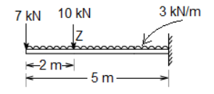 | L3 | 10M | CO2
3 | Draw the bending moment and shear force diagrams for the beam shown in  the figure.  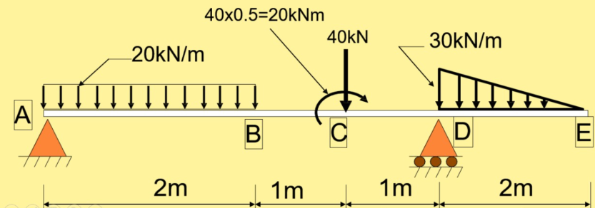 | L3 | 10M | CO2
4 | Construct the bending moment and shear force diagrams for the beam shown in the figure.  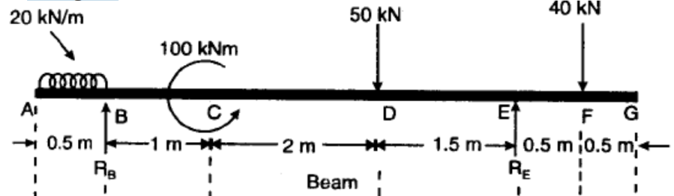 | L3 | 10M | CO2
5 | A beam 10 kN long and simply supported at each end, has a uniformly distributed load of 1000 N/m extending from the left end upto the centre of the beam. There is also an anti-clockwise couple of 15 kNm at a distance of 2.5 m from the right end. Draw the S.F. and B.M. diagrams. | L3 | 10M | CO3
6 | - State the relation between shear force and bending moment.  - Define section modulus with example. | L2  L2 | 5M  5M | CO2  CO2
7 | Derive pure bending equation with assumptions. | L2 | 10M | CO2
8 | Draw the bending moment and shearing force diagrams for  - A Cantilever beam carrying gradually varying load from zero at fixed end and w/unit length at the free end  - A Cantilever beam carrying a moment M at free end | L2  L2 | 5M  5M | CO2
9 | A square beam 20 mm x 20 mm in section and 2 m long is supported at the ends. The beam fails when a point load of 400 N is applied at the centre of the beam. What uniformly distributed load per metre length will break a cantilever of the same material 40 mm wide, 60 mm deep and 3 m long ? | L3 | 10M | CO2
10 | A beam is simply supported and carries a uniformly distributed load of 40 KN/m run over the whole span. The section of the hewn is rectangular having depth as 500 mm. If the maximum stress in the material of the beam is 120 Allnun2 and moment of inertia of the section is 7 x 10⁸ mm², find the span of the beam. | L3 | 10M | CO2

Branches: ME
Regulation: R19
Subject with Code: STRENGTH OF MATERIALS (19CE0150)
Year & Sem: II-B.Tech &I-Sem
SIDDARTHA INSTITUTE OF SCIENCE & TECHNOLOGY, PUTTUR
Siddharth Nagar, Narayanavanam Road – 517583

QUESTION BANK (DESCRIPTIVE)

UNIT III
(Shear Stress Distribution, Torsion of Circular Shafts and Springs)
1 | Define shear stress and derive shear stress distribution formula for rectangular and circular section with a neat sketch. | L1 | 10M | CO3
2 | A timber beam of rectangular section is simply supported at the ends and carries a point load at the centre of the beam. The maximum bending stress is 12 N/mm2 and maximum shearing stress is 1 N/mm², find the ratio of the span to the depth. | L3 | 10M | CO3
3 | Derive shear stress distribution formula for triangular section with a neat sketch. | L2 | 10M | CO3
4 | An I-section beam 350 mm x 150 mm has a web thickness of 10 mm and a flange thickness of 20 mm. If the shear force acting on the section is 40 kN, find the maximum shear stress developed in the I-section.  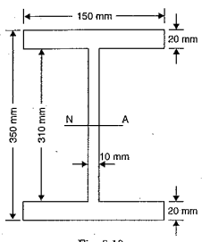 | L2 | 10M | CO3
5 | Draw shear stress distribution diagrams for the following  - Rectangle  - Triangle  - Symmetrical I section  - Symmetrical T section  - Circular section  - L section | L1  L1  L1  L1  L1  L1 | 2M  2M  2M  2M  2M  2M | CO3  CO3  CO3  CO3  CO3  CO3
6 | Derive pure torsion equation for a circular shaft with assumptions. | L2 | 10M | CO3
7 | (a) State the difference between twisting moment and bending moment.  (b) A solid steel shaft has to transmit 75 kW at 200 r.p.m. Taking allowable shear stress as 70 NImm2, find suitable diameter for the shaft, if the maximum torque trans-mitted at each revolution exceeds the mean by 30% | L1  L3 | 3M  7M | CO3  CO3
8 | The stiffness of a close-coiled helical spring is 1.5 N/mm of compression under a maximum load of 60 N. The maximum shearing stress produced in the wire of the spring is 125 N/mm2. The solid length of the spring (when the coils are touching) is given as 5 cm.  Find :  (i) diameter of wire,  (ii) mean diameter of the coils and  (iii) number of coils required. Take C = 4.5 x 10⁴ N/mm². | L3 | 10M | CO3
9 | A hollow shaft, having an inside diameter 60% of its outer diameter, is to replace a solid shaft transmitting the same power at the same speed. Calculate the percent-age saving in material, if the material to be used is also the same. | L3 | 10M | CO3
10 | A closely coiled helical spring made of 10 mm diameter steel wire has 15 coils of 100 mm mean diameter. The spring is subjected to an axial load of 100 N.  Calculate :  - The maximum shear stress induced,  - The deflection, and  - Stiffness of the spring.  - Take modulus of rigidity, C = 8.16 x 10⁴ N/mm² | L3 | 10M | CO3

Branches: ME
Regulation: R19
Subject with Code: STRENGTH OF MATERIALS (19CE0150)
Year & Sem: II-B.Tech &I-Sem
SIDDARTHA INSTITUTE OF SCIENCE & TECHNOLOGY, PUTTUR
Siddharth Nagar, Narayanavanam Road – 517583

QUESTION BANK (DESCRIPTIVE)

UNIT IV
(Deflection of Beams , Columns)

1 | Derive the relation between slope, deflection, radius of curvature. | L2 | 10M | CO4
2 | A beam of uniform rectangular section 200 mm wide and 300 mm deep is simply supported at its ends. It carries a uniformly distributed load of 9 kN/m run over the entire span of 5 m. If the value of E for the beam material is 1 x 10⁴ N/mm², find :  (i) The slope at the supports and  (ii) Maximum deflection. | L3 | 10M | CO4
3 | Determine : (i) slope at the left support, (ii) deflection under the load and (iii) maximum deflection of a simply supported beam of length 5 m, which is carrying a point load of 5 kN at a distance of 3 m from the left end. Take E = 2 x 10⁵ N/mm² and I =1 x 10⁸ mm⁸. | L3 | 10M | CO4
4 | A cantilever of length 3 in carries two point loads of 2 kN at the free end and 4 kN at a distance of 1 m from the free end. Find the deflection. at the free end. Take E = 2 x 10⁵ N/mm2 and I = 10⁸ mm4  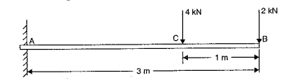 | L3 | 10M | CO4
5 | A horizontal beam AB is simply supported at A and B, 6 m apart. The beam is subjected to a clockwise couple of 300 kNm at a distance of 4 m from the left end as shown in figure below If E = 2 x 10⁵ N/mm2 and I= 2 x 10⁸ mm⁴, determine :  - Deflection at the point where couple is acting and  - The maximum deflection.  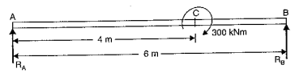 | L3 | 10M | CO4
6 | (a) Write the assumptions made in the Euler’s column theory.  (b) Write the end conditions for long columns and state the difference between long columns and short columns. | L2  L2 | 3M  7M | CO5
7 | Derive an expression for crippling load when both ends of the column are hinged. | L2 | 10M | CO5
8 | A solid round bar 3 m long and 5 cm in diameter is used as a strut with both ends hinged. (Take E = 2.0 x 10⁵ N/mm²)  Determine the crippling load, when the given strut is used with the following conditions :  - One end of the strut is fixed and the other end is free  - Both the ends of strut are fixed  - One end is fixed and other is hinged. | L3 | 10M | CO5
9 | A column of timber section 15 cm x 20 cm is 6 metre long both ends being fixed. If the Young's modulus for timber =17.5 kN/mm², determine :  - Crippling load and  - Safe load for the column if factor of safety = 3. | L3 | 10M | CO5
10 | Using Euler's formula, calculate the critical stresses for a series of struts having slenderness ratio of 40, 80, 120, 160 and 200 under the following conditions :  - both ends hinged and  - both ends fixed. Take E = 2.05 x 10⁵ N/ mm² | L3 | 10M | CO5

Branches: ME
Regulation: R19
Subject with Code: STRENGTH OF MATERIALS (19CE0150)
Year & Sem: II-B.Tech &I-Sem
SIDDARTHA INSTITUTE OF SCIENCE & TECHNOLOGY, PUTTUR
Siddharth Nagar, Narayanavanam Road – 517583

QUESTION BANK (DESCRIPTIVE)

UNIT V
(Thin Cylinders and Thick Cylinders)

1 | A cylindrical thin drum 80 cm in diameter and 3 m long has a shell thickness of 1 cm. If the drum is subjected to an internal pressure of 2.5 N/mm², Take E= 2x 10 5 N/mm² Poisson’s ratio 0.25  Determine  (i) change in diameter  (ii) change in length and  (iii) change in volume. |  | L3 | 10M | CO6
2 | A cylindrical shell 100 mm long 200mm internal diameter having thickness of a metal as 10 mm is filled with a fluid at atmospheric pressure. If an additional 200 mm³ pumped into the cylinder, Take E = 2 X 10 ⁵ N/ mm² and Poisson’s ratio is 0.3Find  (i) The pressure exerted by the fluid on the cylinder and  (ii) The hoop stress induced. |  | L3 | 10M | CO6
3 | A copper cylinder, 90 cm long, 40 cm external diameter and wall thickness 6 mm has its both ends closed by rigid blank flanges. It is initially full of oil at atmospheric pressure. Calculate additional volume of oil which must be pumped into it in order to raise the oil pressure to 5 N/mm² above atmospheric pressure. For copper assume E= 1.0 x 10⁵ N/mm² and Poisson’s ratio 1/3. Take bulk modulus of oil as K= 2.6 x 10³ N/mm². |  | L3 | 10M | CO6
4 | A closed cylindrical vessel made of steel plates 4 mm thick with plane and, carries fluid under a pressure of 3 N/ mm². The dia, of cylinder is 30 cm and length is 80 cm , calculate the longitudinal and hoop stresses in the cylinder wall and determine the change in diameter, length and volume of the cylinder. Take E = 2 X 10 ⁵ N/ mm² and Poisson’s ratio is 0.286 |  | L3 | 10M | CO6
5 | A cast iron pipe 200 mm internal diameter and 12 mm thick is wound closely with a single layer of circular steel wire of 5 mm diameter, under a tension of 60 N/mm2. Find the initial compressive stress in the pipe section. Also find the stresses set up in the pipe and steel wire, when water under a pressure of 3.5 N/mm² is admitted in to the pipe.  Take E = 1 x 105 N/mm2 for cast iron and for steel E = 2 x 105 N/mm2.poisson’s ratio isgiven as 0.3. |  | L3 | 10M | CO6
6 | Derive an expression for hoop and radial stresses across thickness of the thick cylinder |  | L2 | 10M | CO6
7 | Determine the maximum and minimum hoop stress across the section of a pipe of 400 mm internal diameter and 100 mm thick, when the pipe contains a fluid at a pressure of 8 N/mm². Also sketch the radial pressure and hoop stress distribution across the section. |  | L3 | 10M | CO6
8 | A compound cylinder is made by shrinking a cylinder of external diameter 300 mm and internal diameter of 250 mm over another cylinder of external diameter 250 mm and internal diameter 200 mm. The radial pressure at the junction after shrinking is 8 N/mm² . Find the final stresses set up across the section, when the compound cylinder is subjected to an internal fluid pressure of 84.5 N/mm². |  | L3 | 10M | CO6
9 | A steel cylinder of 300 mm external diameter is to be shrunk to another steel cylinder of 150 mm internal diameter. After shrinking, the diameter at the junction is 250 mm and radial pressure at the common junction is 28 N/mm² . Find the original difference in radii at the junction. Take E = 2 x 10⁵ N/mm². |  | L3 | 10M | CO6
10 | A thin cylindrical shell with following dimensions is filled with a liquid atmospheric pressure : Length =1.2 m, external diameter = 20 cm, thickness of metal = 8 mm. Find the value of the pressure exerted by the liquid on the walls of the cylinder and the hoop stress induced if an additional volume of 25 cm³ of liquid is pumped into the cylindertake E = 2.1 x 10⁵ N/mm2 and Poisson's ratio = 0.33. |  | L3 | 10M | CO6

Prepared By: A.SANYASI RAJU

